**Surabhi Asati**

**STAT – 6610**

**Homework assignment-2**

1. Try out the Weather Underground website. Find the current temperature of a city of your choice. Try WonderMap also. Print Screen the picture and turn it in.

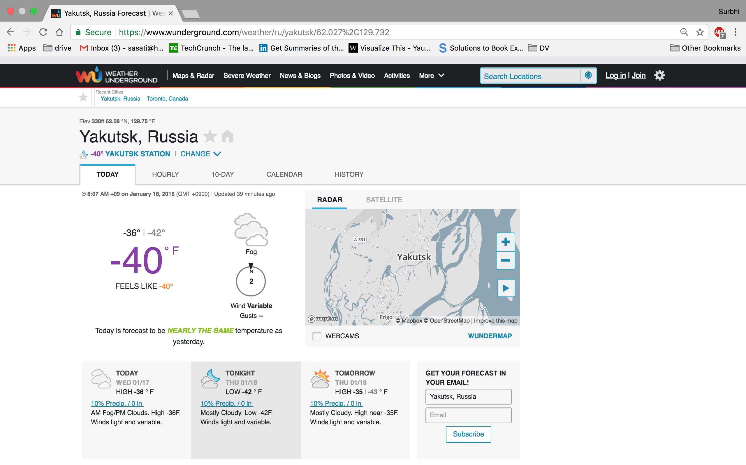

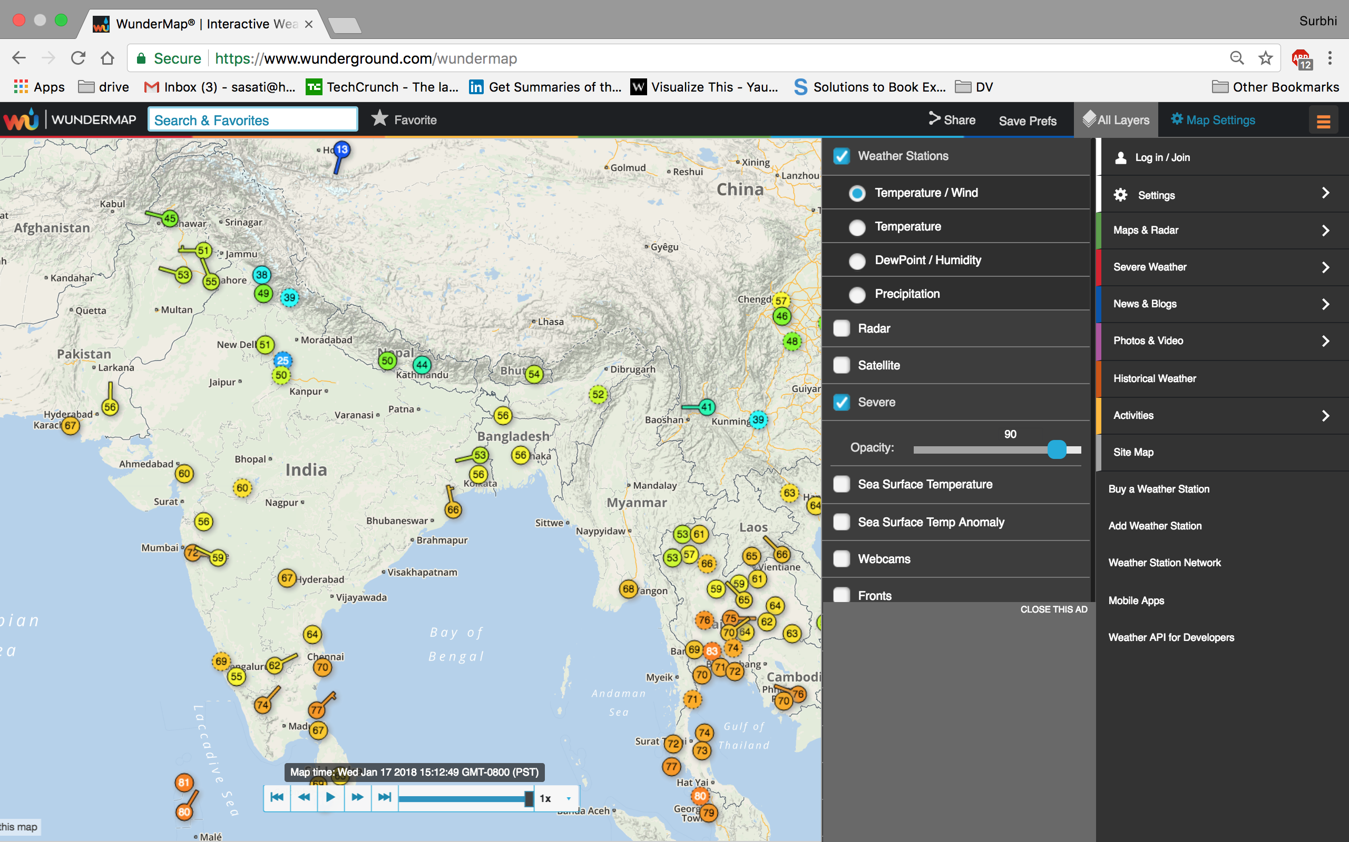

1. Use [quantmod](http://www.quantmod.com/) to download stock market data directly into R. Make similar plots to the ones you made using the yahoo finance webpage for Homework 1 now using the [quantmod](http://www.quantmod.com/) library in R. Use the example code in [stocks03.R](http://www.sci.csueastbay.edu/~esuess/classes/Statistics_6610/Homework/yahoo/stocks03.R). Show the plots you have created in your homework document.

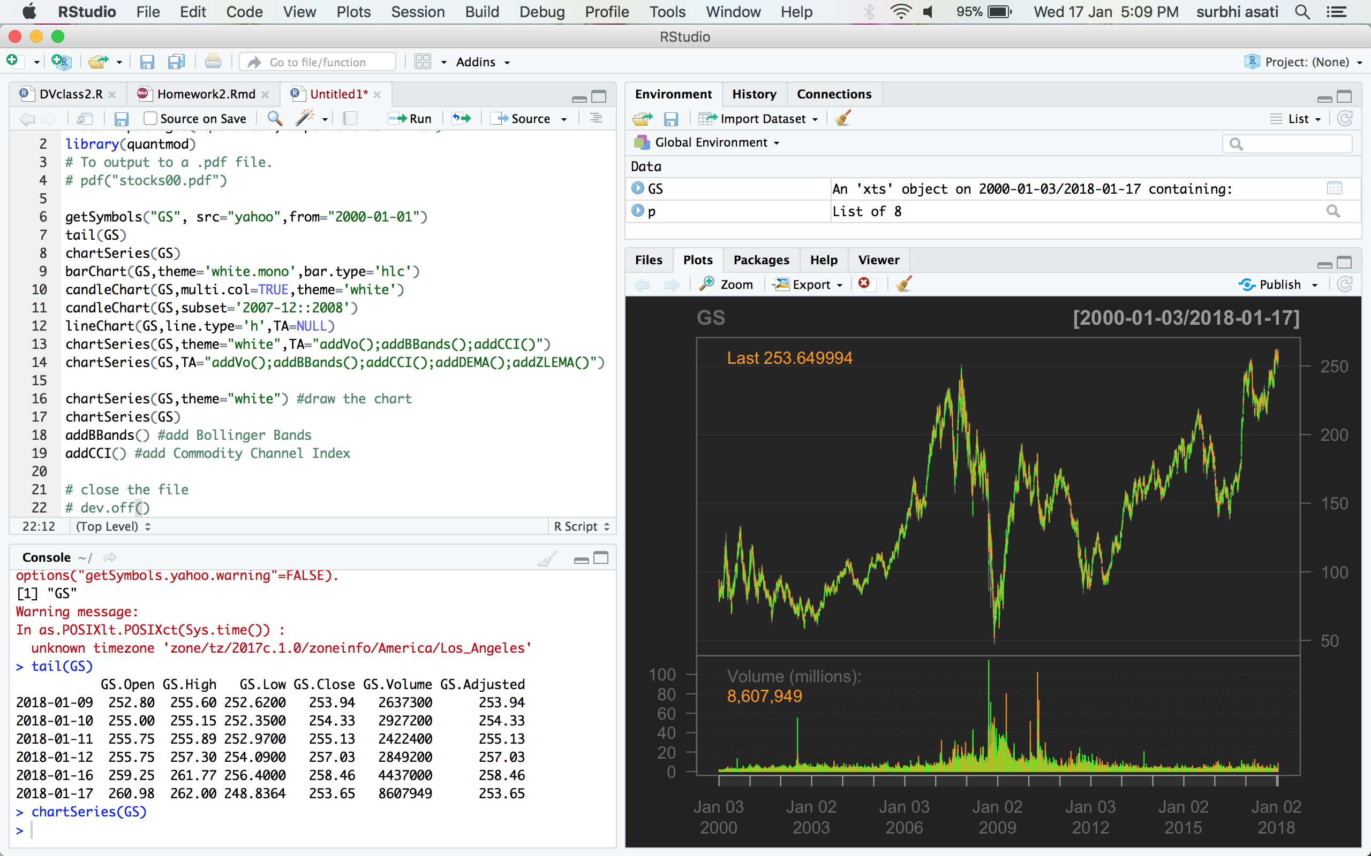

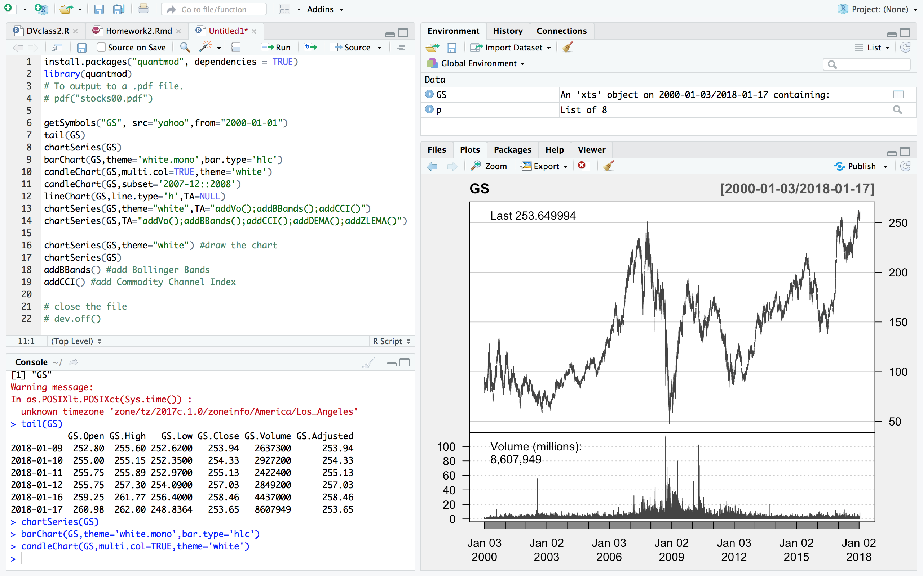

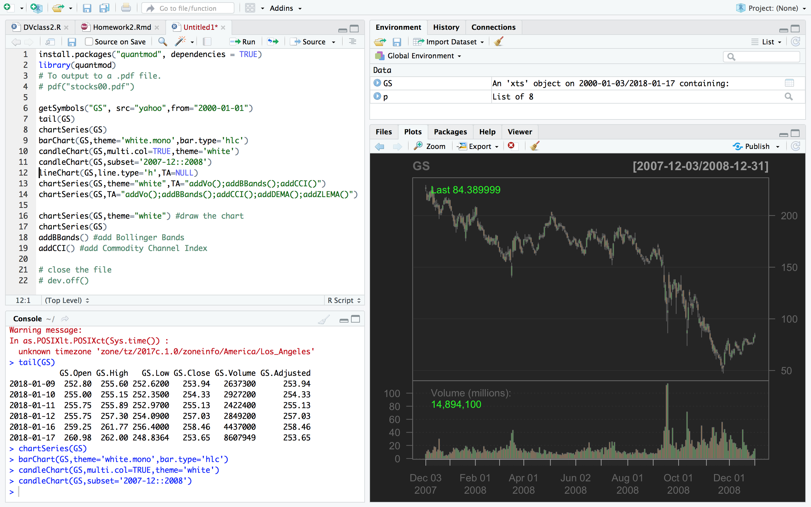

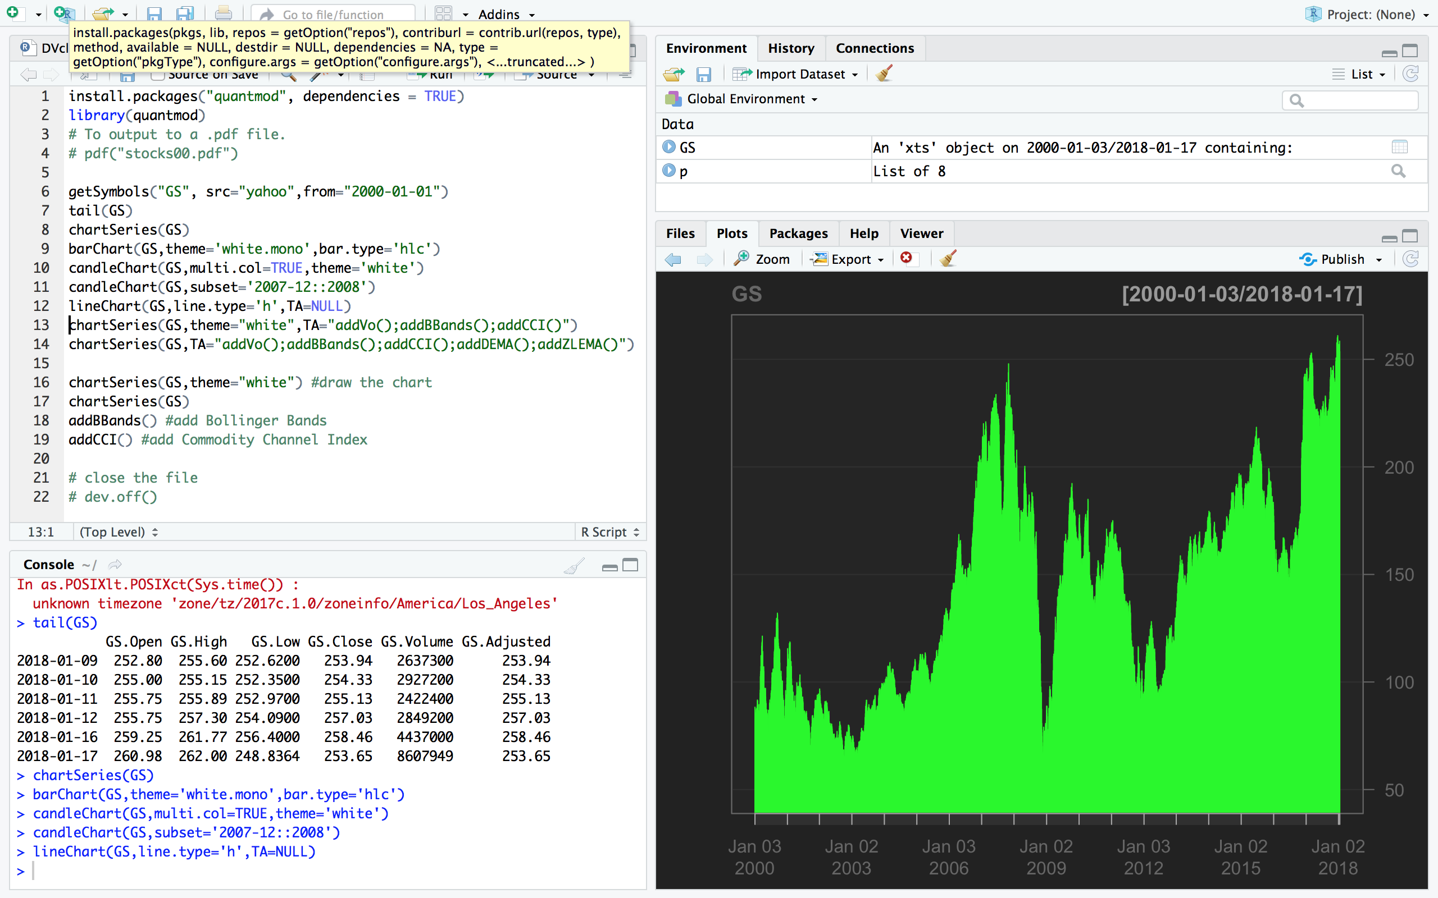

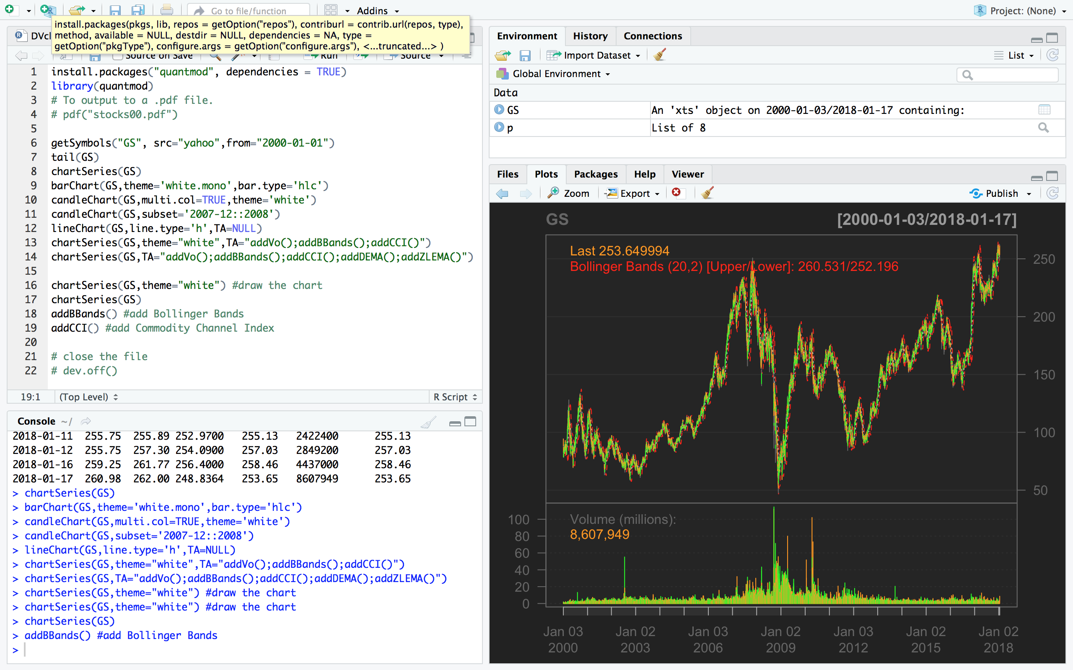

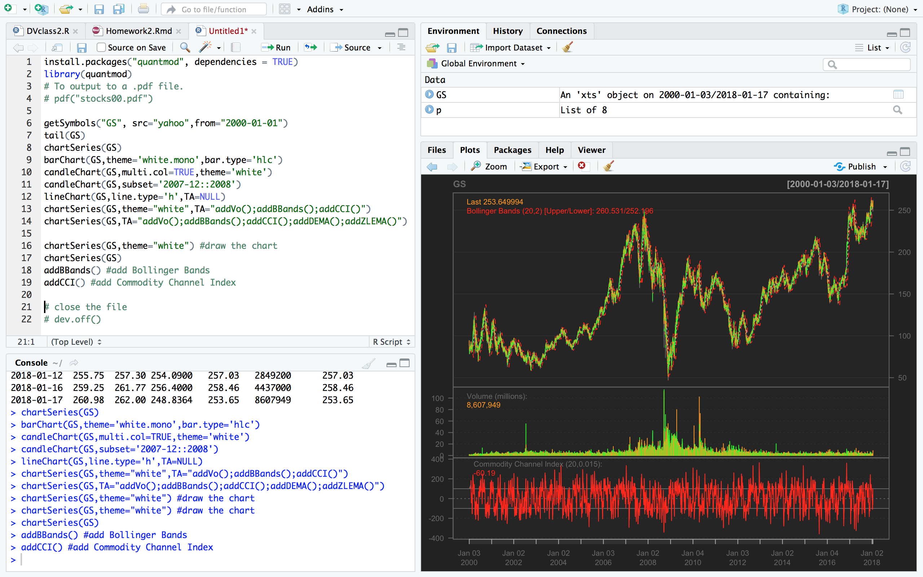

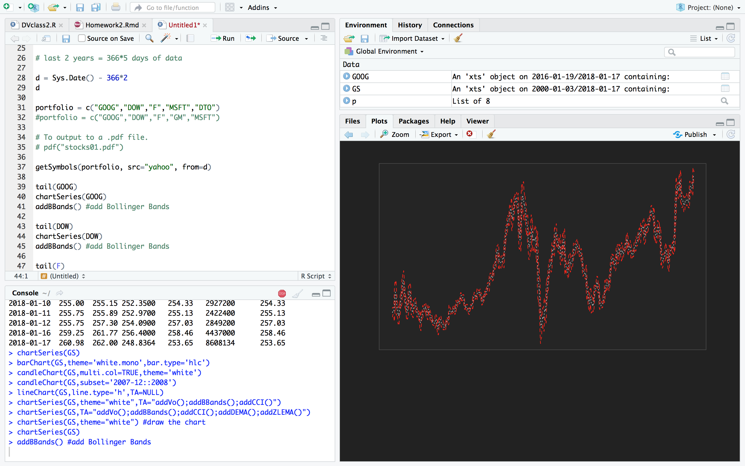

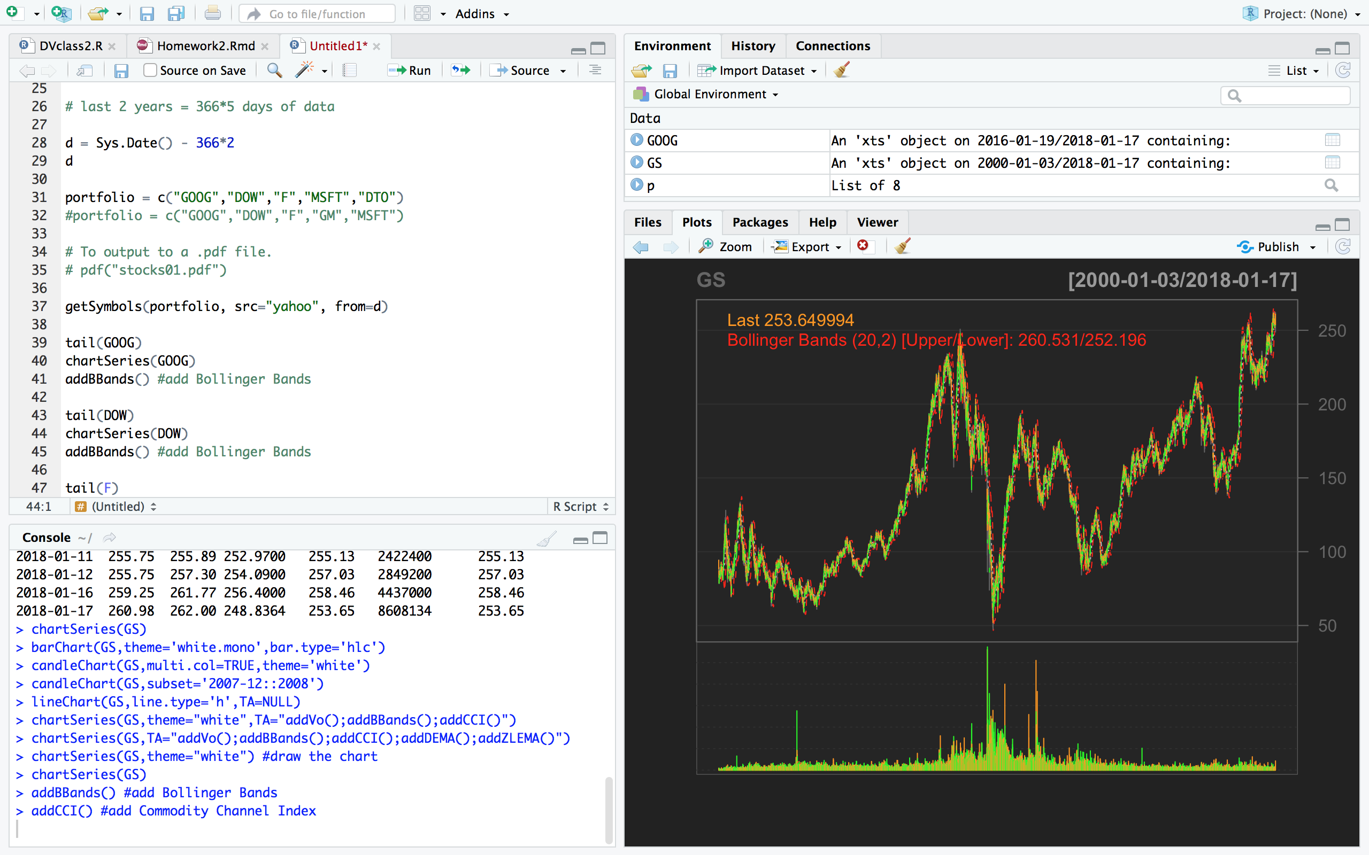

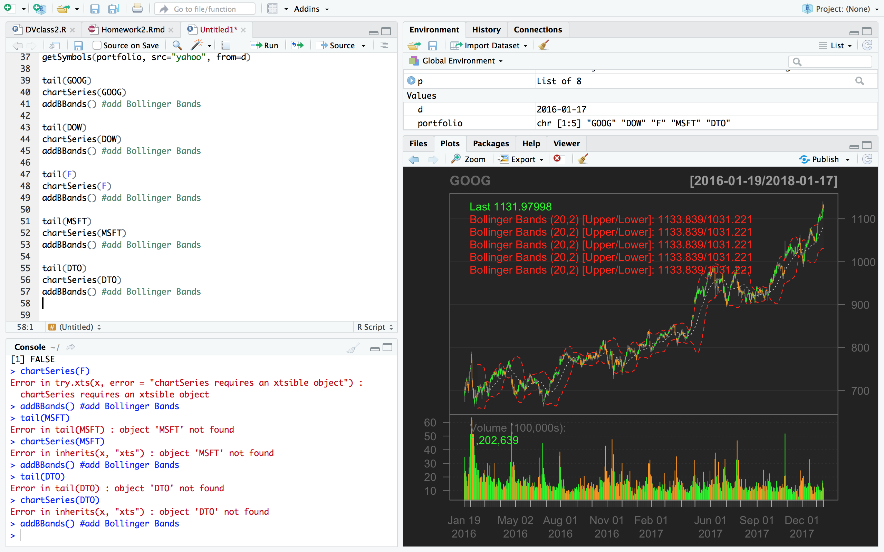

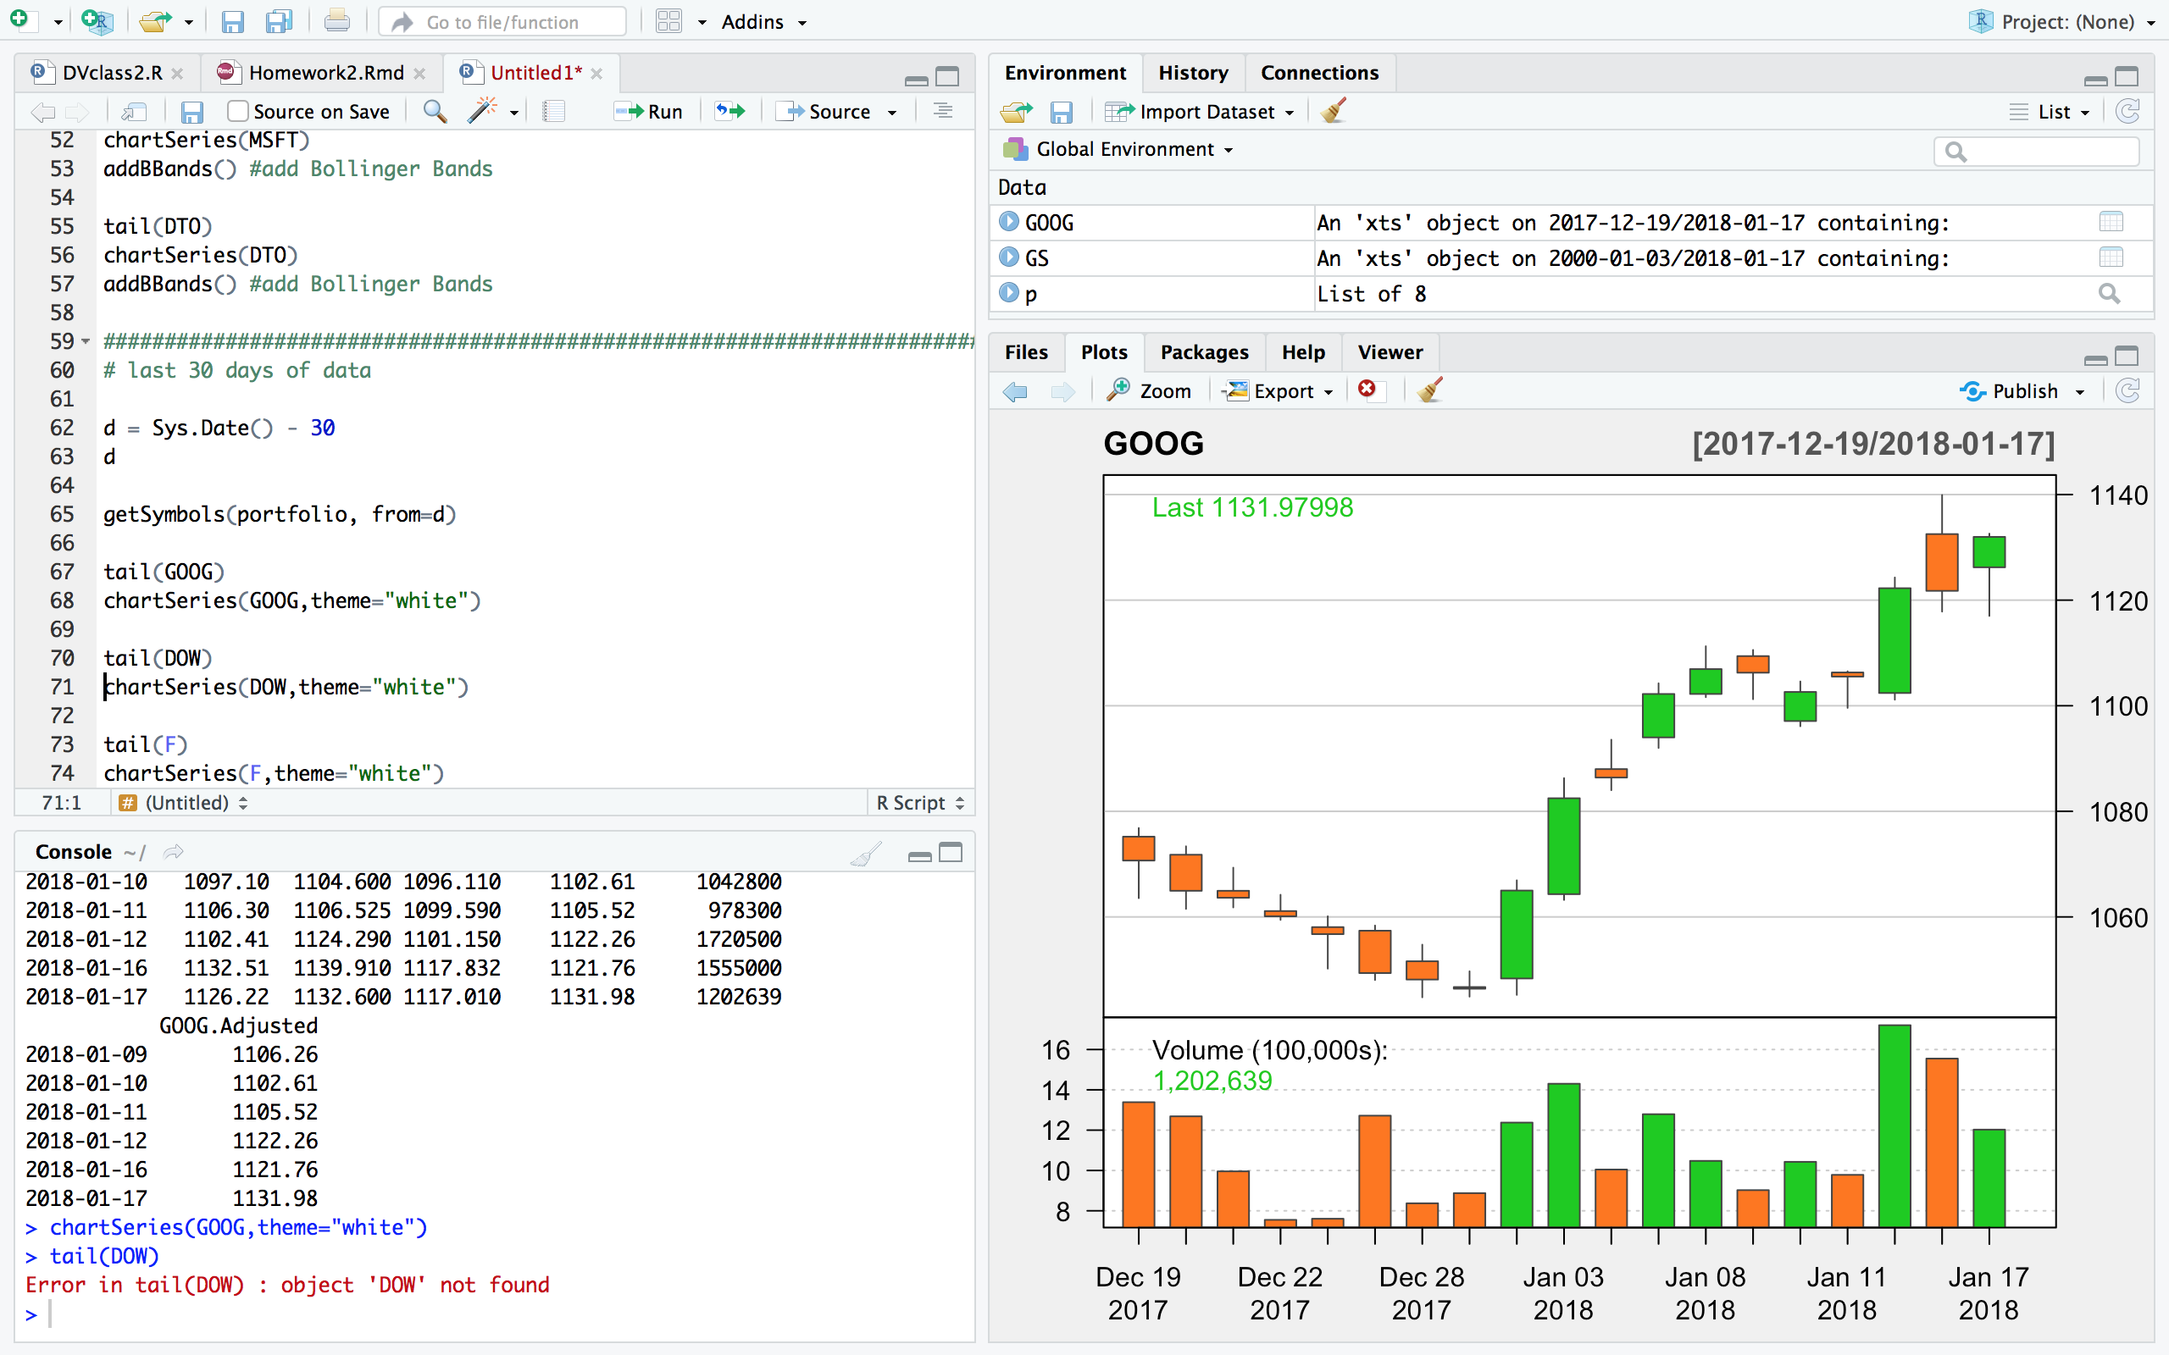

1. Choose 4 more stocks and update the code in [stocks03.R](http://www.sci.csueastbay.edu/~esuess/classes/Statistics_6610/Homework/yahoo/stocks03.R) Save the plots for your portfolio. Comment on how the stock market is doing currently.  
   Show the plots you have created in your homework document.

Taking Stock information for: Facebook, Amazon, Netflix and Bitcoin USD

Alphabet, Facebook and Amazon has a long and robust growth trajectory ahead. Bitcoin ticked slightly higher today. Bitcoin has maintained about 50% of the market share in crypto currency but has lost traction over the past month.

**Facebook:**

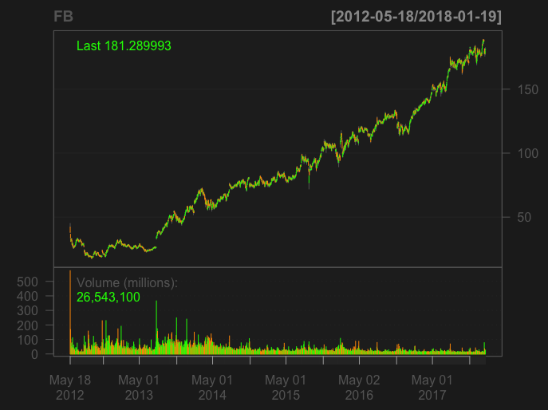

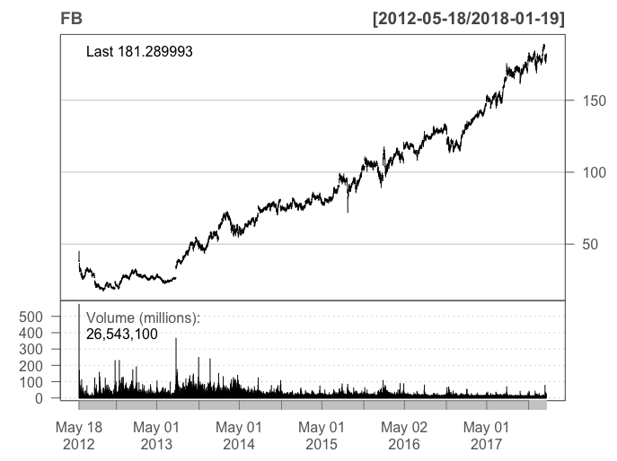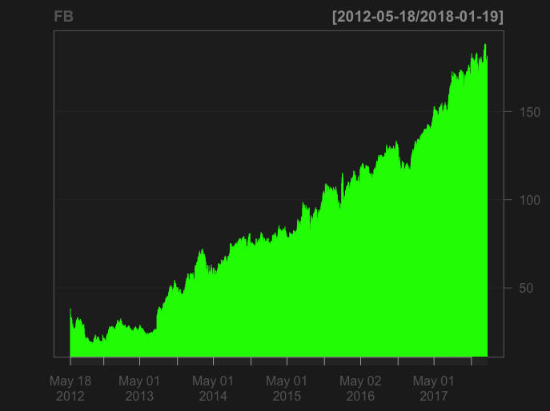

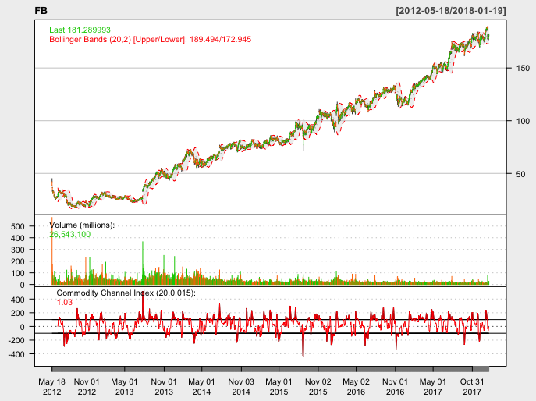

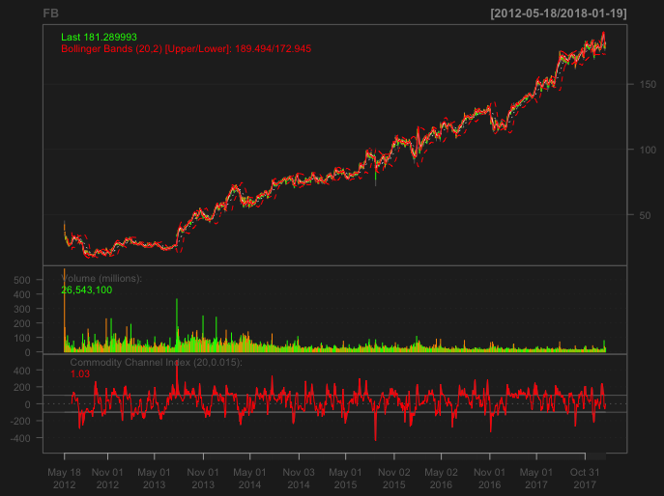

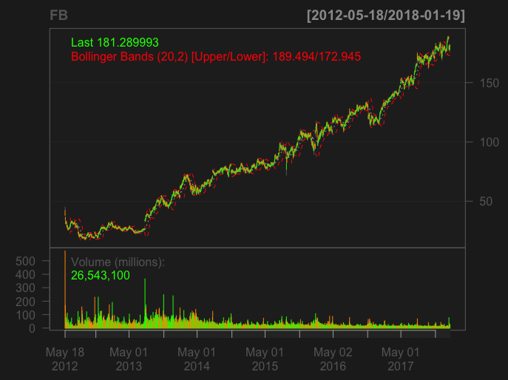

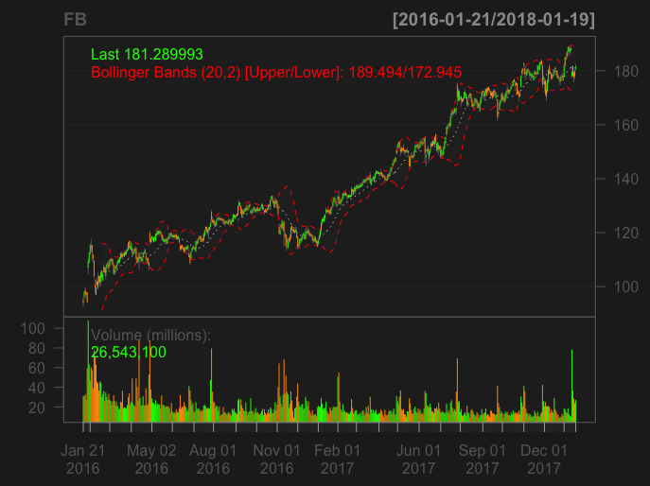

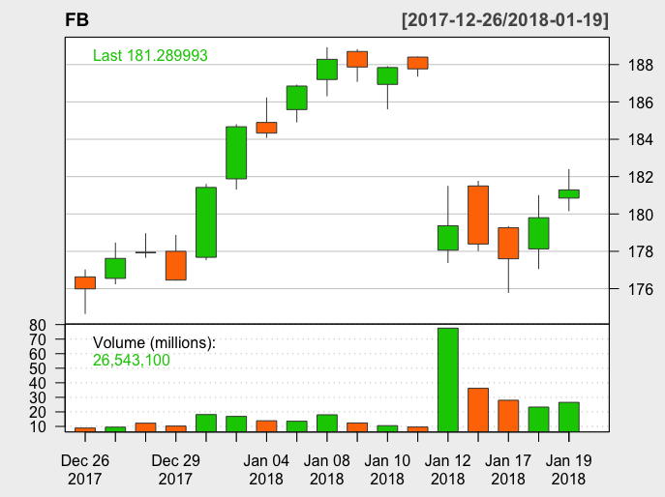

**Amazon:**

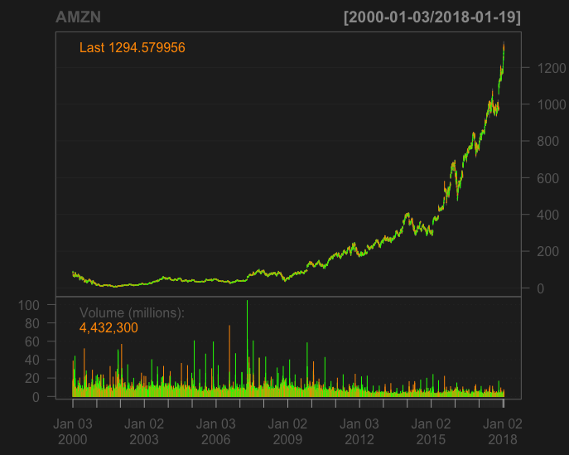

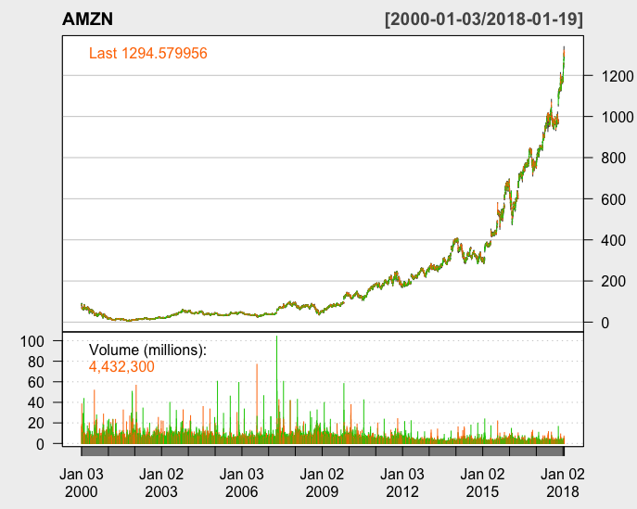

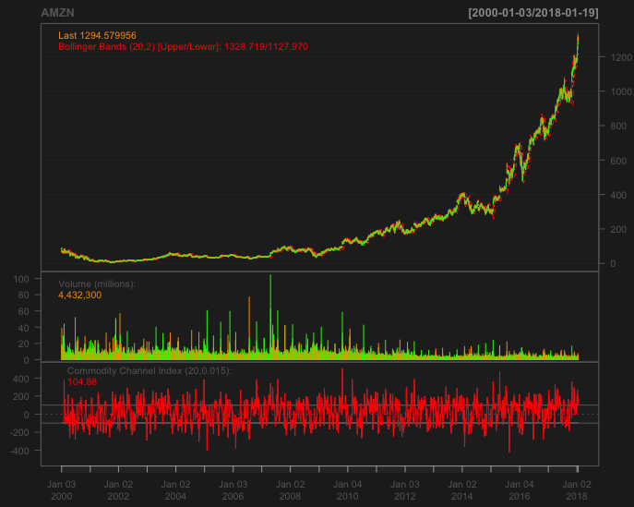

**Netflix:**

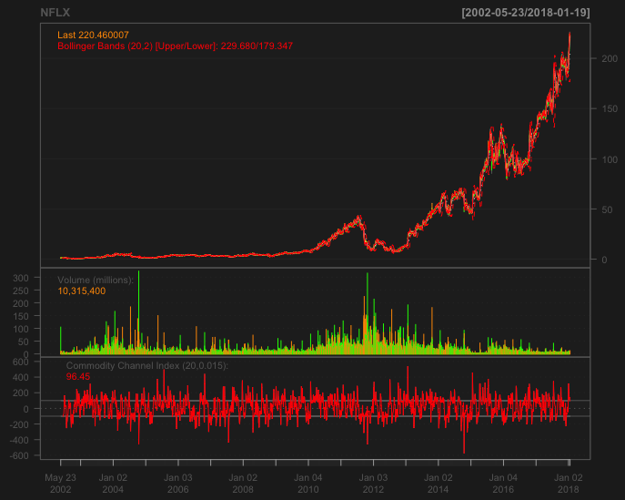

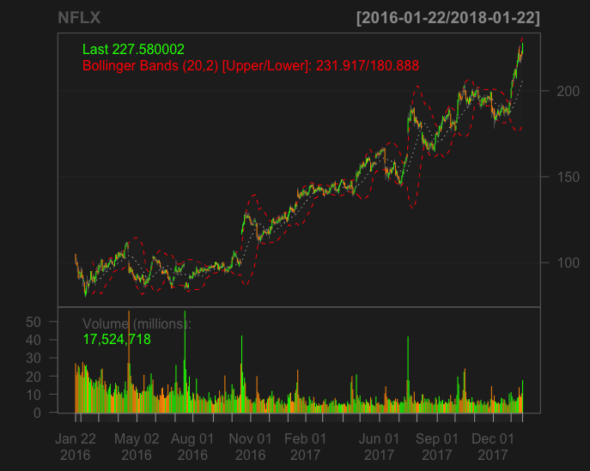

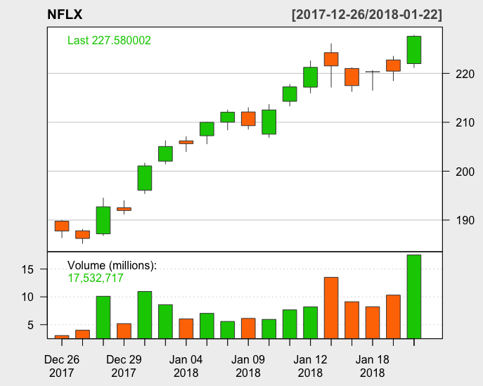

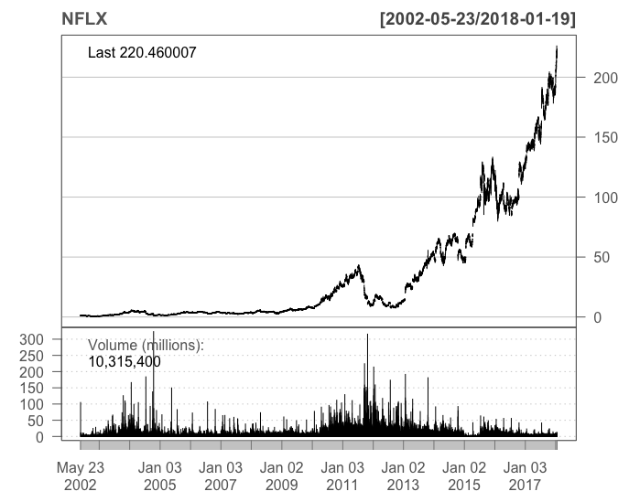

**Bitcoin USD (BTC-USD):**

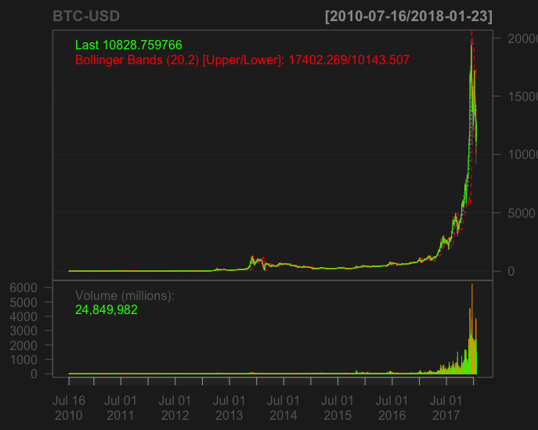

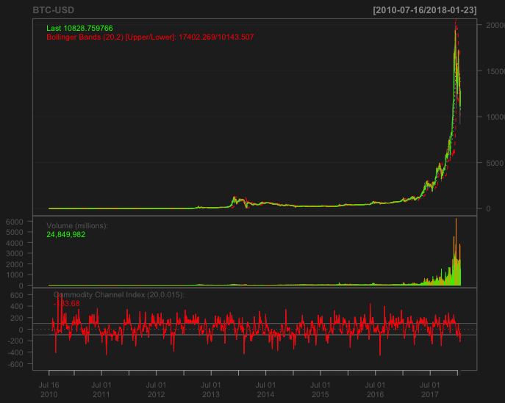

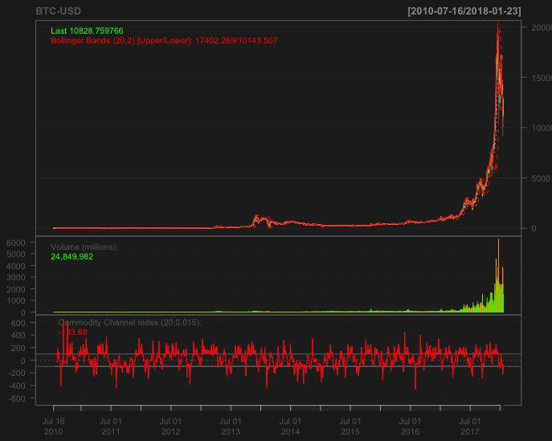

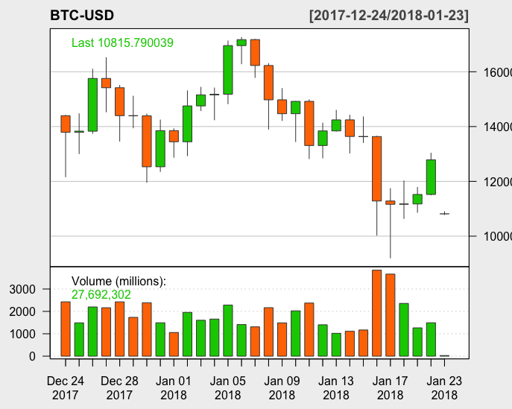

1. Using R run the mtcars examples from the end of the [DataScraping](http://www.sci.csueastbay.edu/~esuess/classes/Statistics_6610/viz/viz3/DataScraping.html#/) presentation. Show the plots you have created in your homework document.

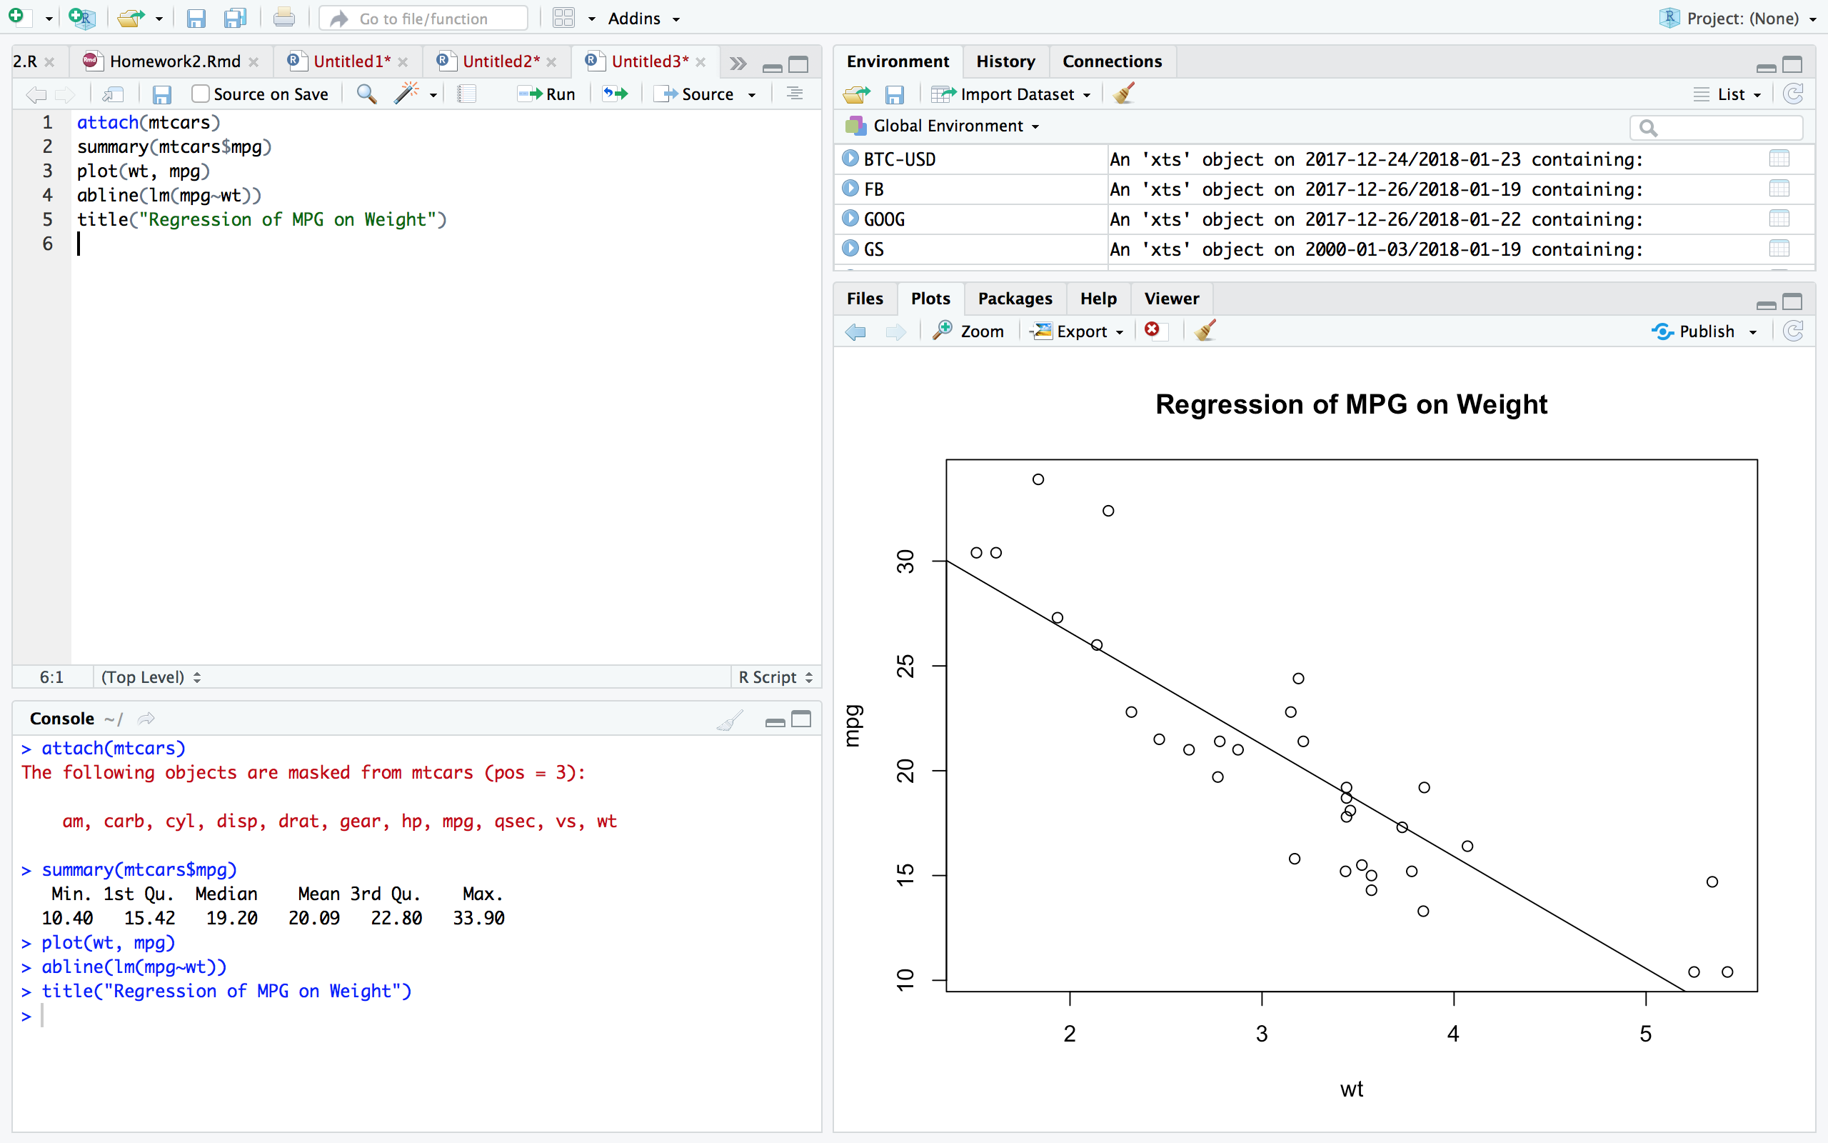

1. From the [Quick-R](https://www.statmethods.net/) website, run the R programs to make plots for the mtcars data. See the [Basic Graphs](https://www.statmethods.net/graphs/index.html) link. Show each plot.
   1. [Density Plots](https://www.statmethods.net/graphs/density.html)

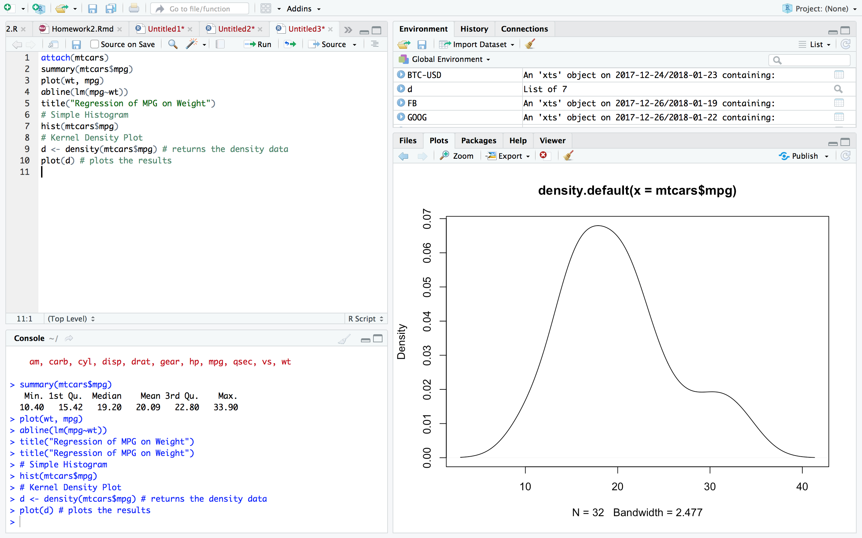

* 1. [Dot Plots](https://www.statmethods.net/graphs/dot.html)



* 1. [Bar Plots](https://www.statmethods.net/graphs/bar.html)

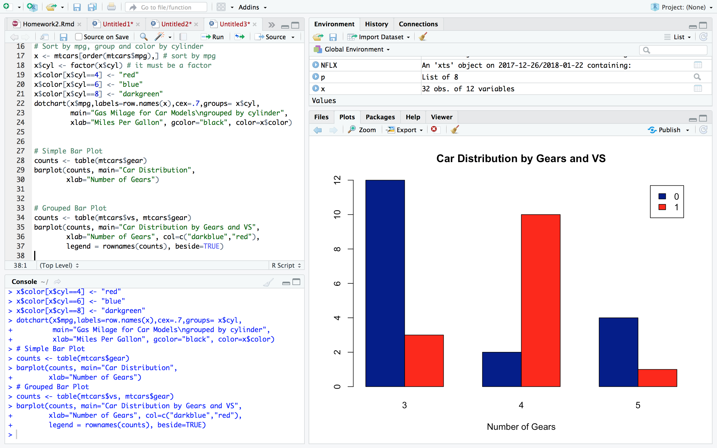

* 1. [Line Charts](https://www.statmethods.net/graphs/line.html)

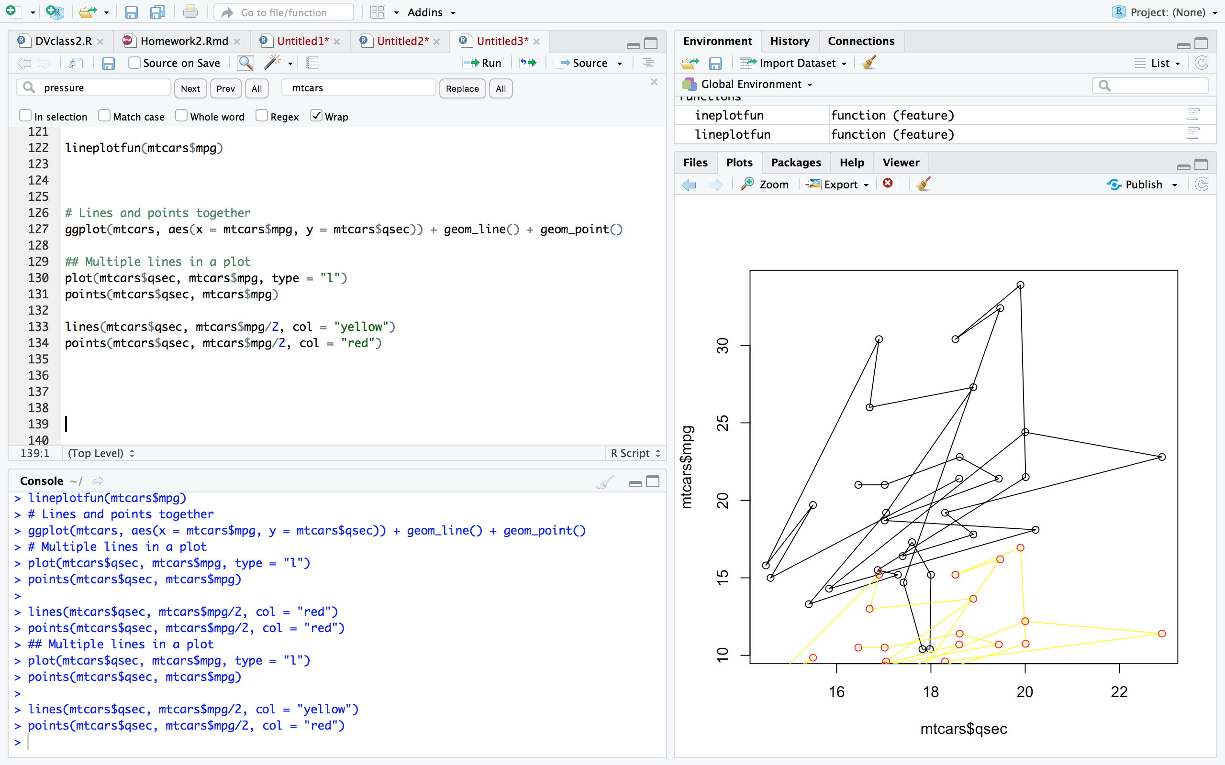

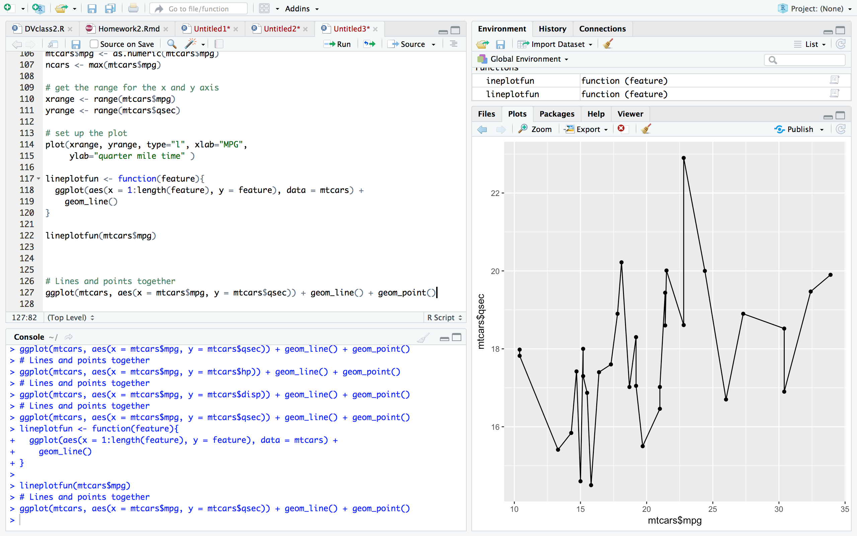

* 1. [Pie Charts](https://www.statmethods.net/graphs/pie.html)

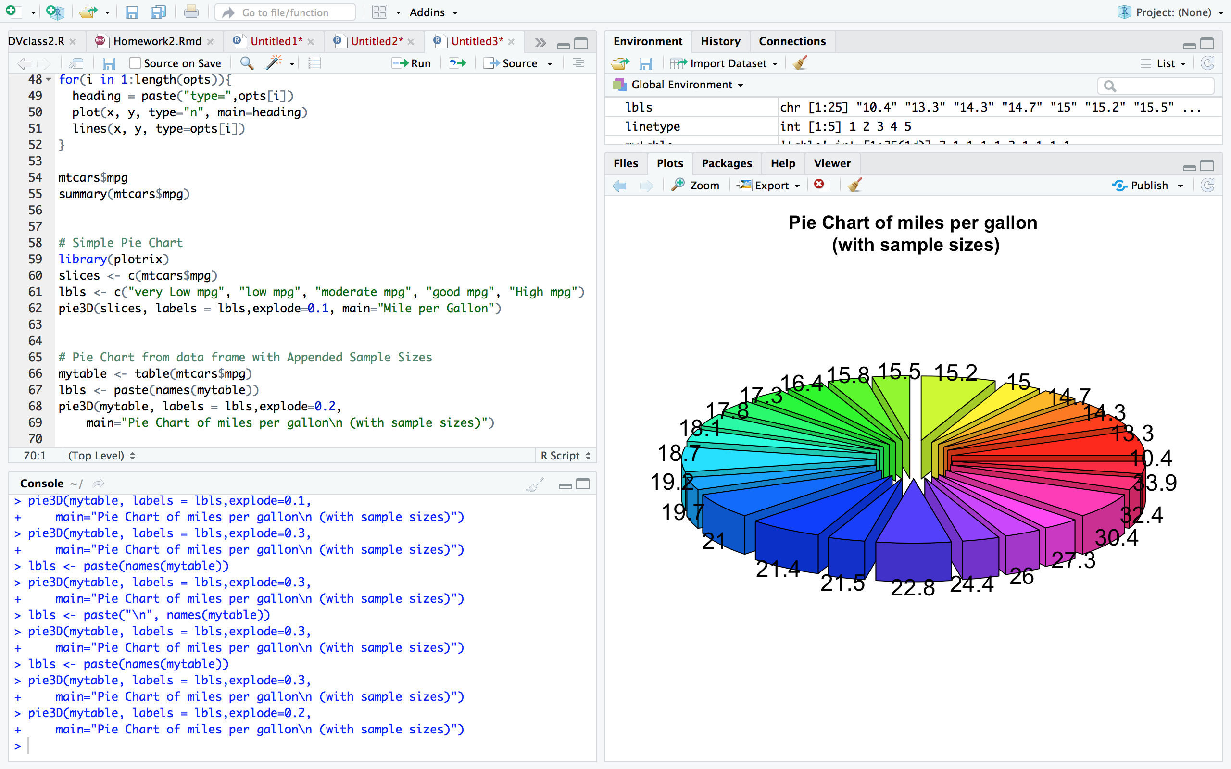

* 1. [Boxplots](https://www.statmethods.net/graphs/boxplot.html)

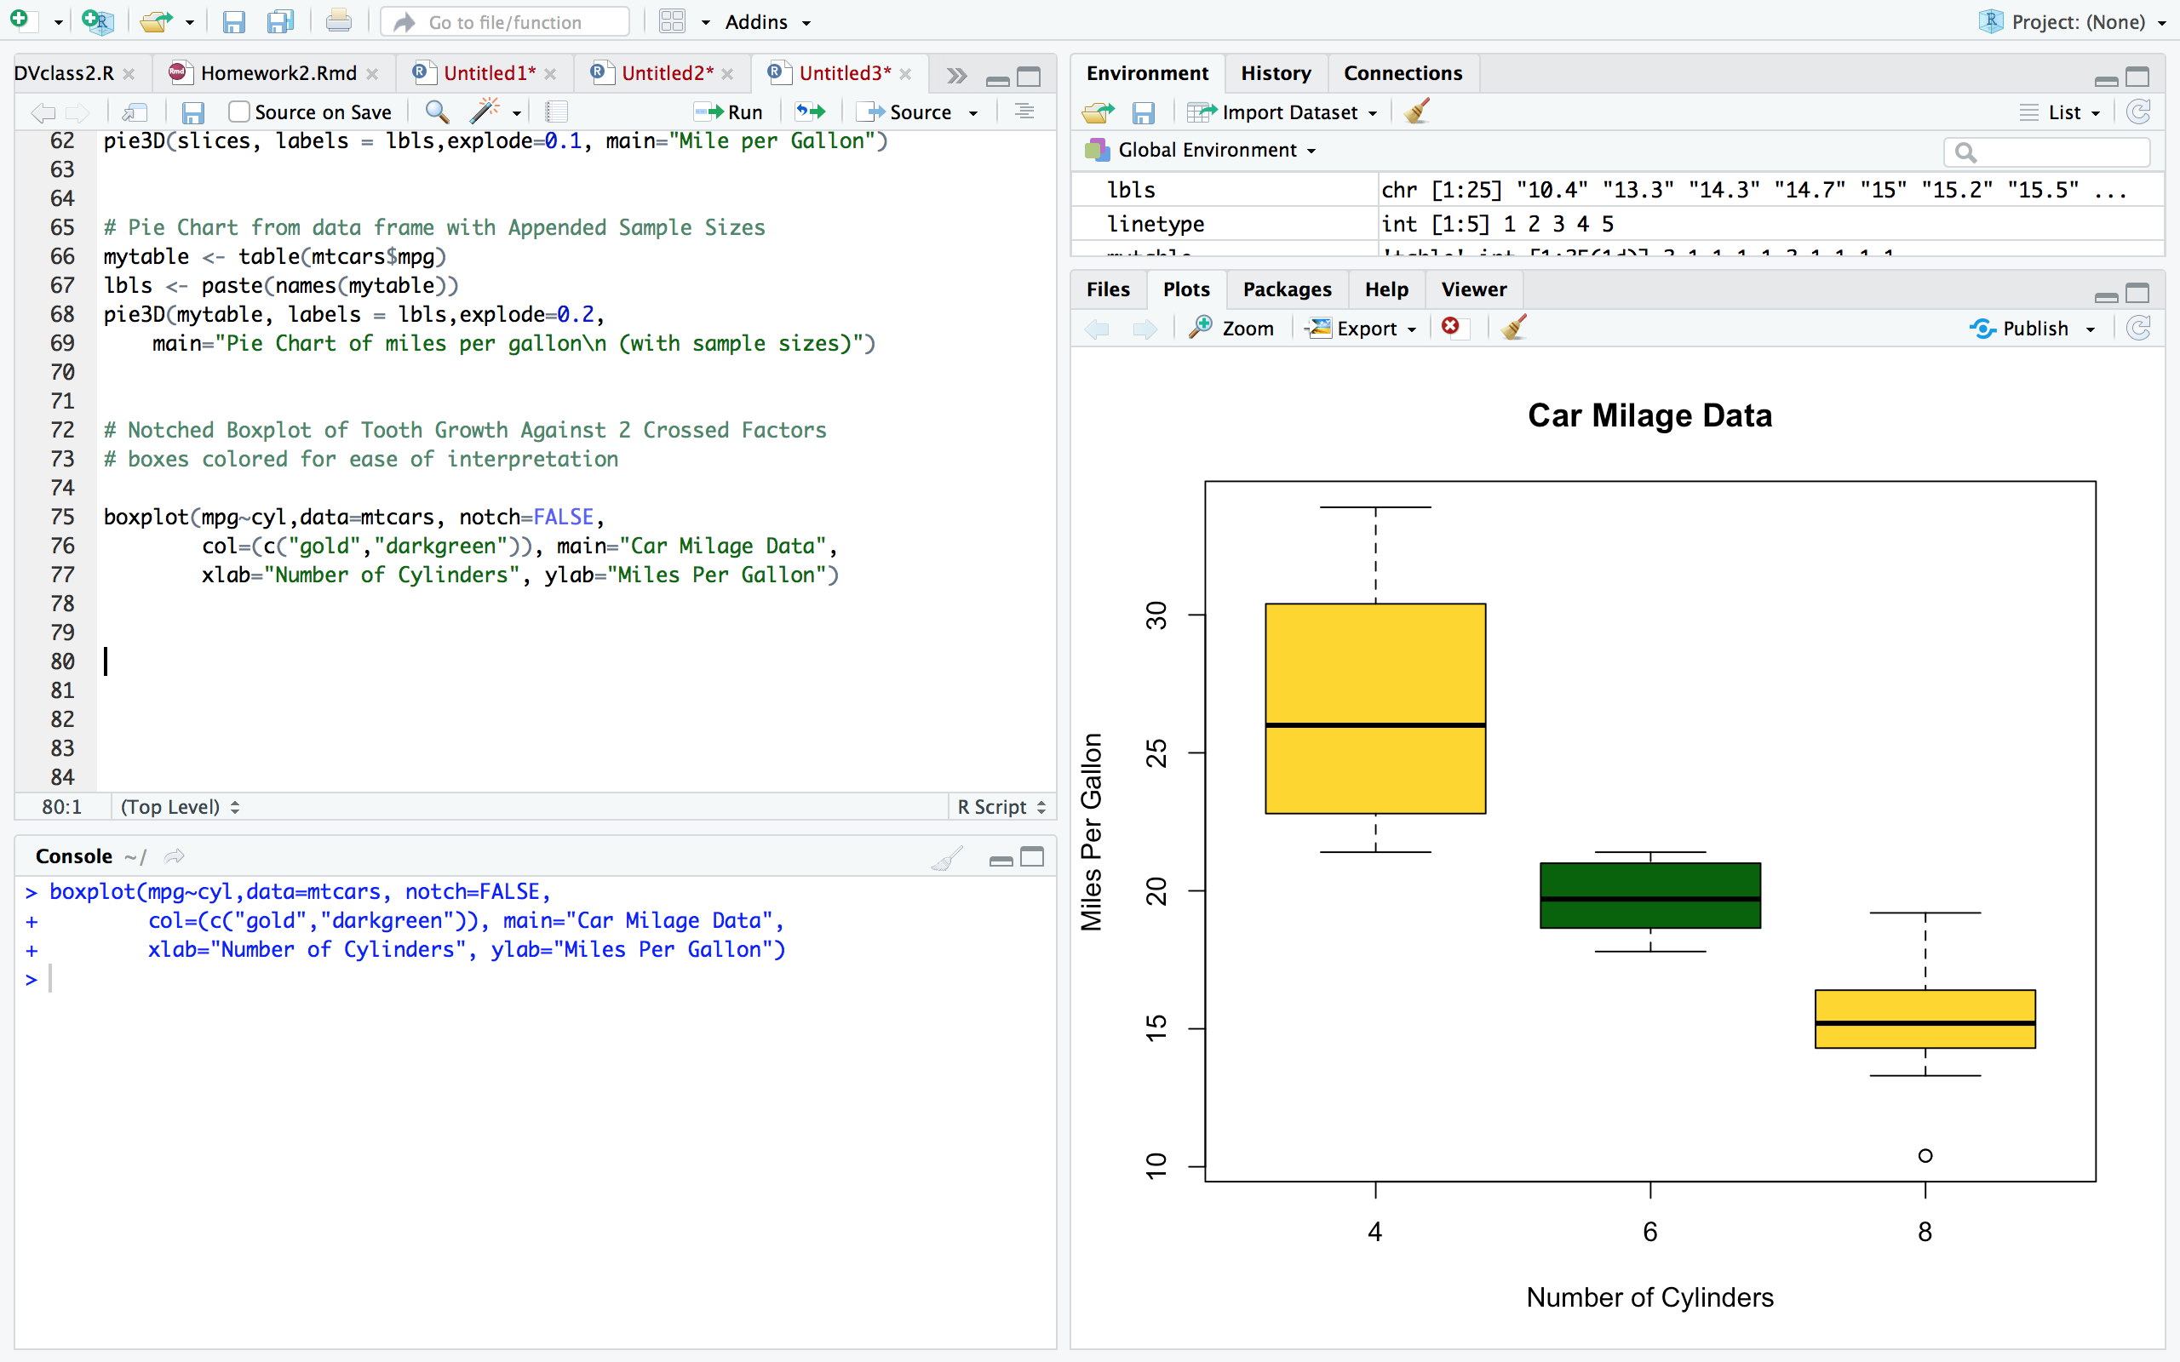

* 1. [Scatter Plots](https://www.statmethods.net/graphs/scatterplot.html)

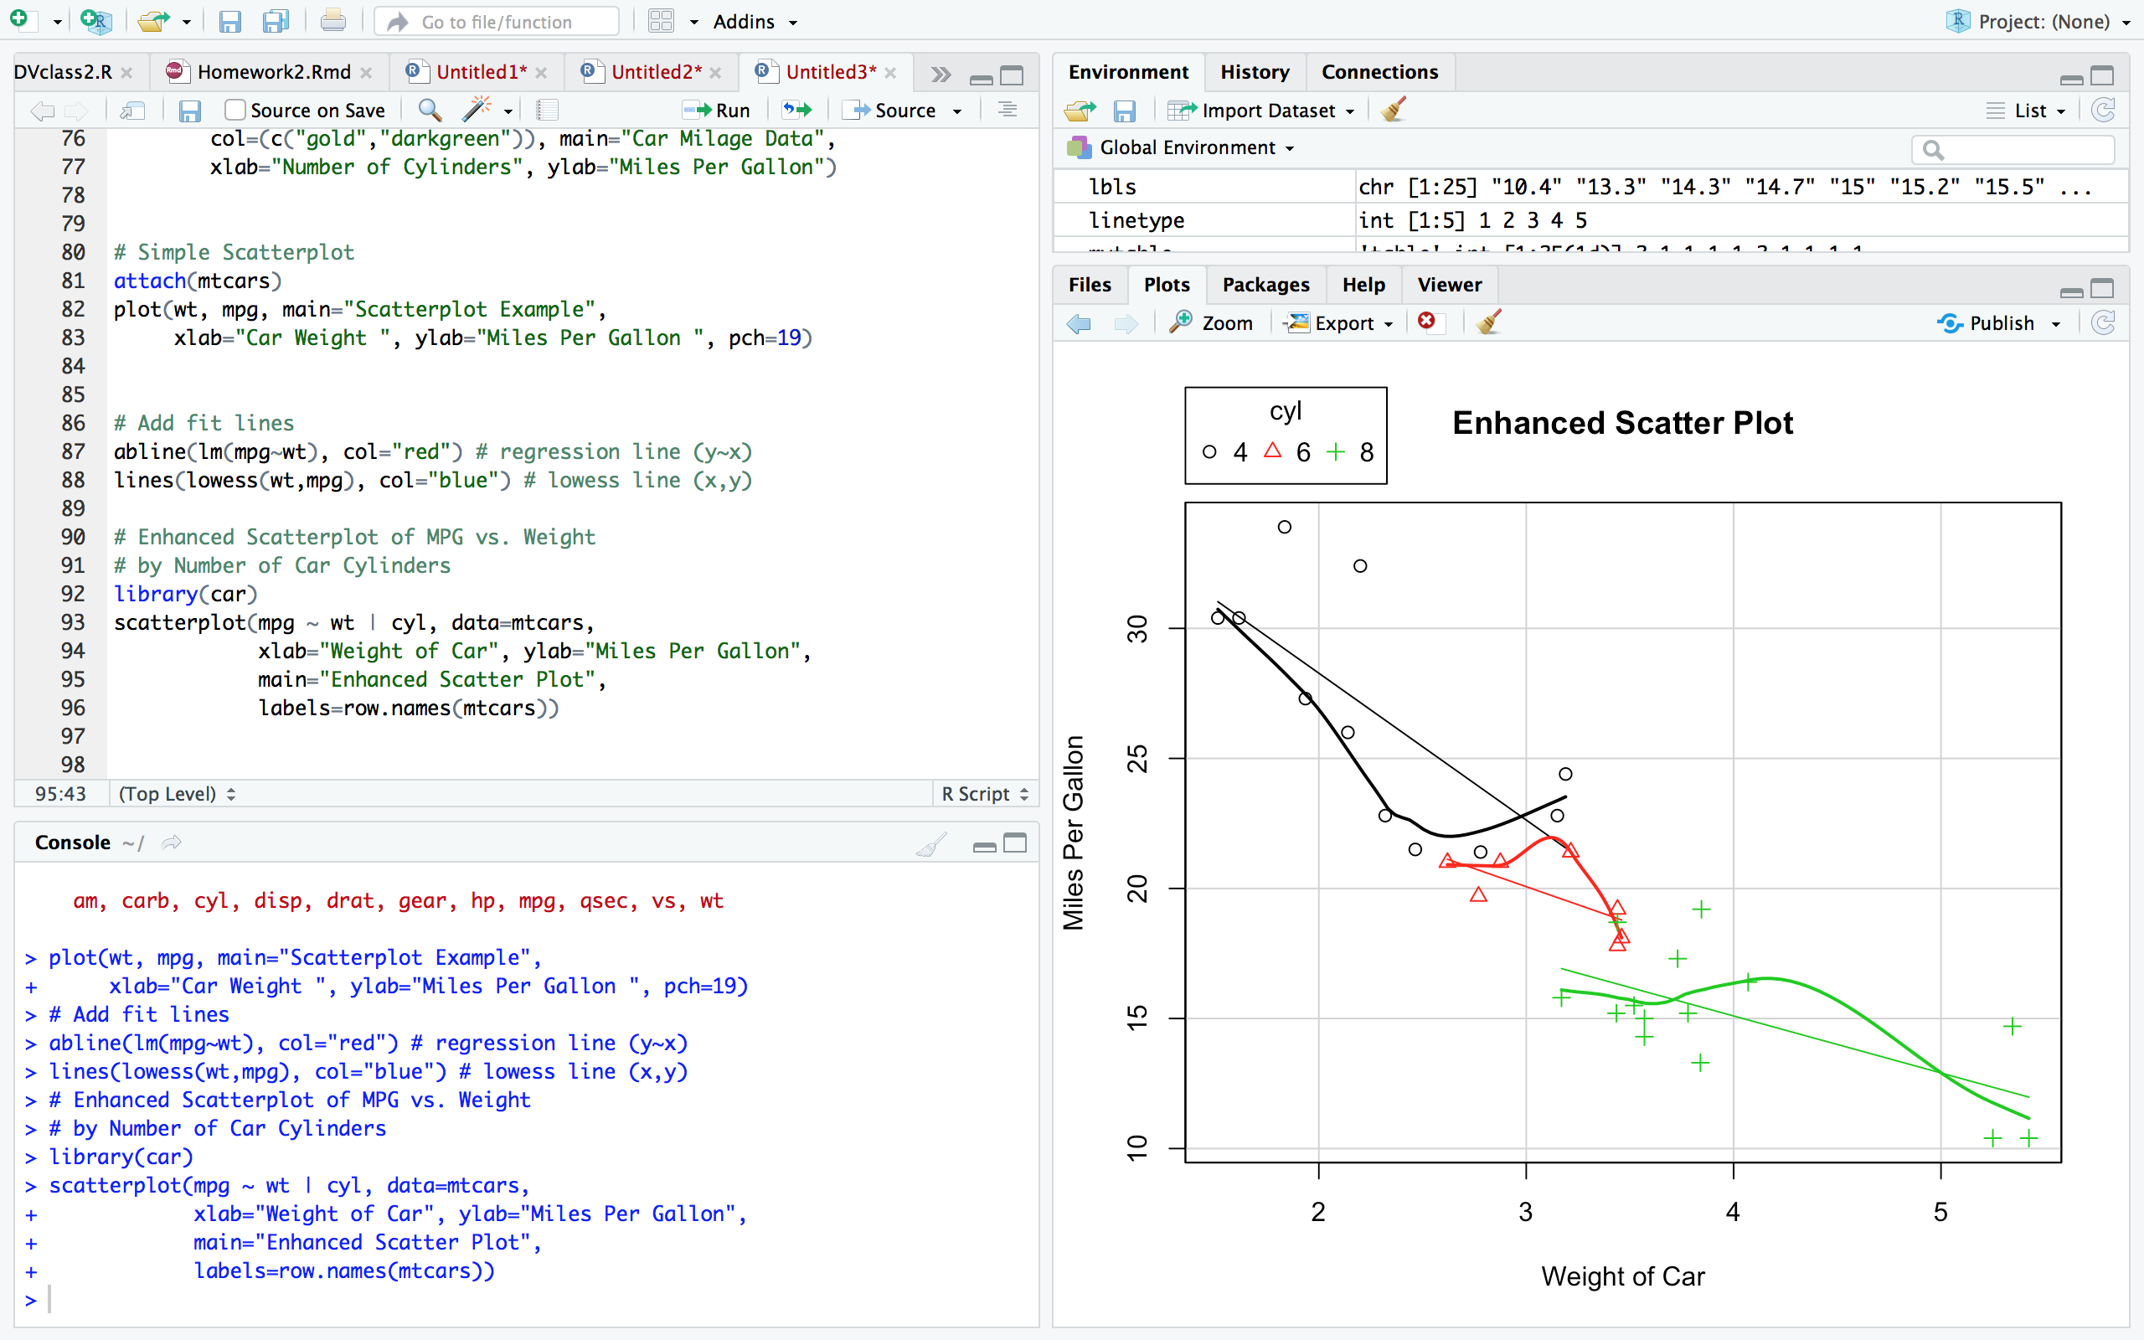

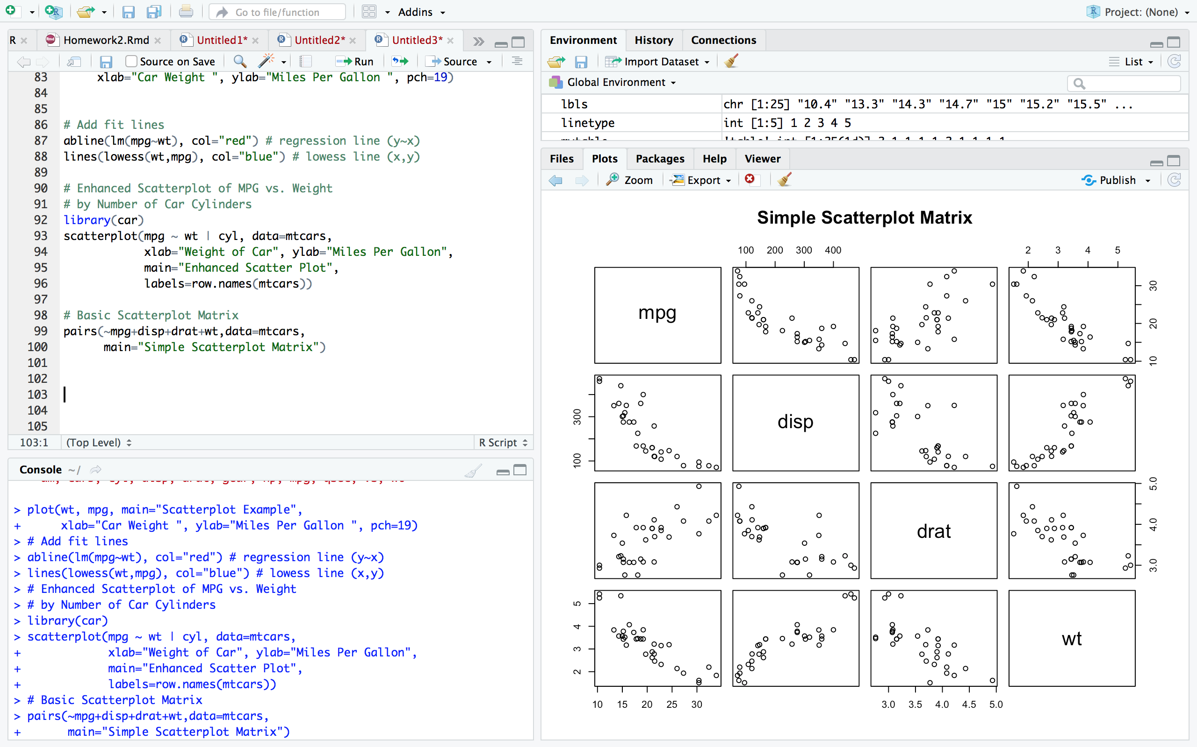

1. Find the Parking meters dataset from DataSF and produce some data visualizations using the tools provided on the website, in Excel and in tableau public. Show the plots you have created in your homework document. Before you start try to think of a question to answer before you start making plots. For example, are there more or less smart meters in SF than non-smart meters?

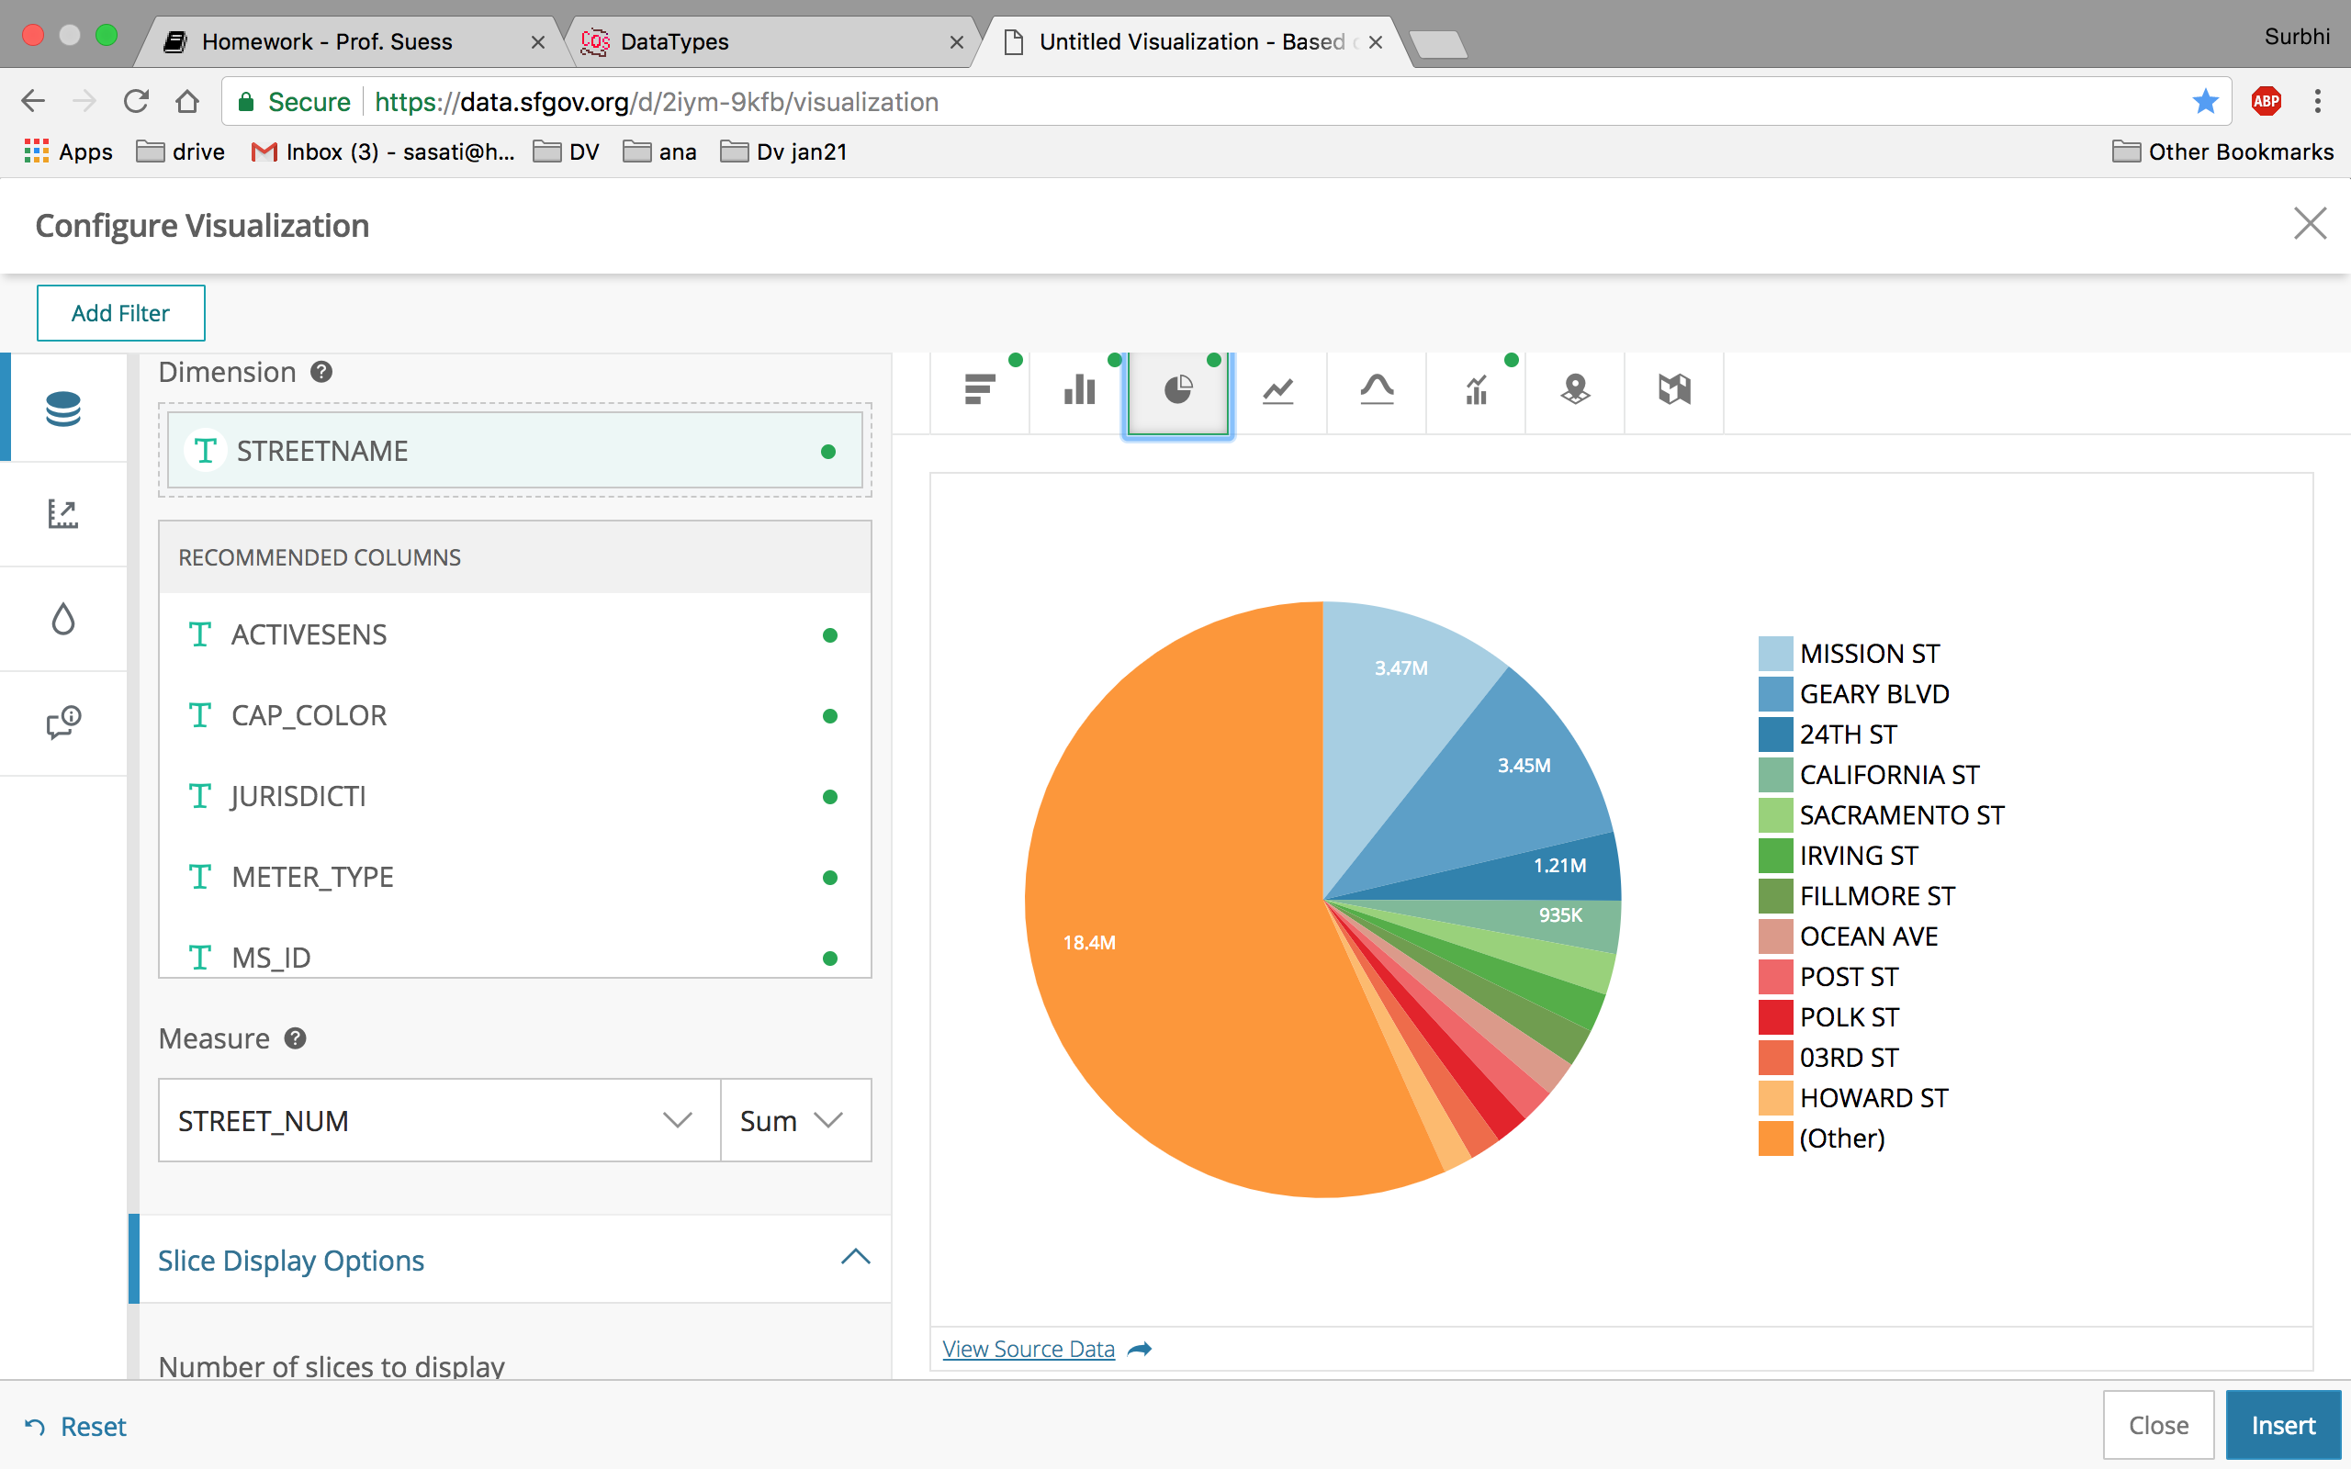

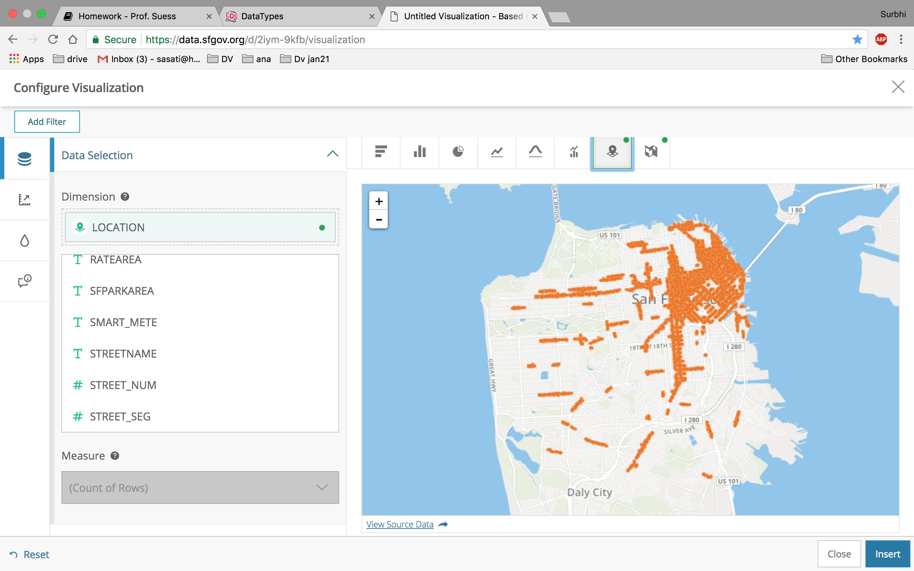

Using Tableau:

